Practice Exam for MIS400 – Winter 2012

Create a web page and five different web methods to modify records in the Northwind Database, and show requested information. This review contains functionality that is higher than what is needed by the final in an attempt to better prepare you. It is, by no means comprehensive of what can be asked, and should not be taken to be so. Instead, it should be used as a test to see how much you really know.

The First Layer

The top of the page uses a GridView and a DetailsView to display data about products and to allow you to see if your database modifications were successful. This part of the page must be done using GUI controls..

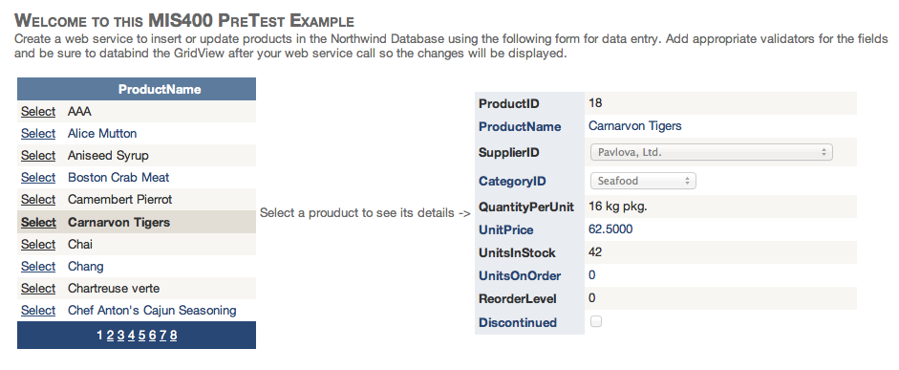

Note: The Supplier ID and Category ID fields in the Details View use drop down lists. You are not required to know how to make those as a part of your Details View.
The Middle Layer

The middle part of the page is used to input data for the changes you wish to make to a Supplier ID that is selected by the Drop Down List corresponding to Supplier, or to a Category ID that corresponds to Category.
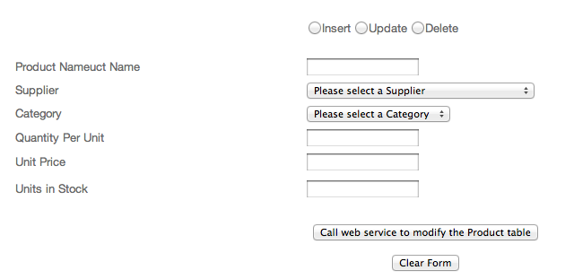
- Selecting the “Insert” radio button should cause the data entered on the form to be passed to a web service that inserts new products in the database. The primary key of this table, ProductID, is an identify specification field (auto number) so it doesn’t have to be provide when the insert is performed.
- Selecting the “Update” button should cause the data entered on the form to be passed to a web service that updates the SELECTED product (because the web service does the update and it could be anywhere in the world, you will need to pass the productID to it along with all the other data.
- Selecting the “Delete” button calls a web service that attempts to delete the selected product (see the note about the product ID under “Update”

You are to write the three web methods indicated above and write code associated with the “Call web services…” button that consumes the appropriate web method based on the radio button selection.

The Last Layer

The last part of this sample exam asks you to write two web methods that retrieve data from the Northwind database.

The first DropDownList to allows the user to choose one of the customers found in the Northwind database. When the selection is changed the page passes the customerID to a web service that counts and returns the total number of orders for that company.

The second DropDownList allows the user to choose one of the customers. When a customer is chosen the second DropDownList is populated with all the products that customer has purchased! When the user selects a product from the second drop down list, a web service is called, passing it the customerID AND the productID. The web service theh calculates and returns the total amount the customer spent on the selected product on all the orders in the system. This should be done by summing the quantity * price * (1-discount) each time the product was sold to that customer.

